Biography according to his website.

Born in 1983, Emeric Lhuisset grew up in suburban Paris. He lives between Middle East and Paris (France).

 Gradueted in arts (Ecole des Beaux-Arts de Paris - Ensba) and in geopolitics (University Panthéon-Sorbonne / Ecole Normale Superieur d’Ulm - Center for geostrategy). He has participated in numerous exhibitions and interventions in France (Centquatre, Espace Electra, Salon d’art contemporain de Montrouge, Frac Alsace, Musée Albert Kahn, Centre Pompidou….) and abroad (Andrea Meislin Gallery in New York, Solar de Beira in Brazil, ARCO Madrid, Galleria do Palacio in Portugal, PAN in Italy, Art Dubaï...). In addition to his art practice, he teaches at the Institute of Political Studies of Paris (Sciences Po) and hosts a cycle of conferences between Sciences Po and New York University (NYU) in Paris about *contemporary art & geopolitics*.

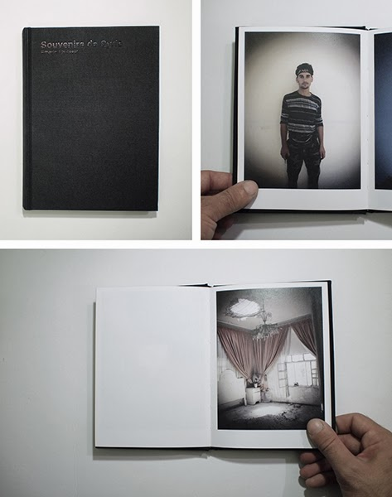

Emeric Lhuisset is an artist that works with the question of contemporary art and geopolitics; he considers his work as an artistic transcription of geopolitical analyses. More specifically he is interested in conflict and in the question of the reality of conflict. What is the reality of conflict, what we see in the media, in the movies or in video games?

Through his works Emeric Lhuisset tries to show what he sees and has experience to be the reality of conflict through his various field trips to conflict zones such as in countries like Afghanistan, Irak, Syria or just recently Ukraine.

For this exhibition we are going to concentrate on his work in Syria and more precisely on his booklet “Souvernirs de Syrie”.

“Souvernirs de Syrie” is a little back artist booklet, on which s first page you can read “These photos were taken between June and August 2012 in the Idlib and Aleppo provinces alongside the Free Syrian Army. » and which is constituted of several little photos taken at that time, for personal purpose only.

Indeed Emeric Lhuisset travelled to Syria between june and august 2012 in order the produce his video art work “***Chebab,*** *plan sequence of a day in the life of Free Syrian Army fighter »,where he fixed a* personal camera on a Free Syrian Army fighter and filmed, 24 hours of his life. During his stay Emeric Lhuisset took picture, for his personal archives, documenting what he sees as the reality of the conflict. One year later, back in Paris he looked at those pictures noticing that he had already forgotten about a lot of them. That is where the process of “Souvernirs de Syrie” begun. He wanted those photos to be seen, but how should he show them? Should he sell them to the media? – No, that was not possible. One-year-old pictures are far to old to interest the media, that works on an immediate transmission of image. Even pictures that are one week old are often already obsolete. So, do these pictures already belong to the memory of the Syrian war? Is it even possible to speak of the memory of an ongoing conflict? That is where the idea of a booklet came up. A small format with pictures what would exclusively be shown in the book in order to create in intimacy in between the viewer and the subject. This booklet is conceived in the form of a little black box, like those boxes we all have and use to stock our souvenirs. This idea of souvenir box actually gave the book its title “Souvernirs de Syrie”. The idea of black box might also evoke another image; the one of the black boxes used in aviation in order to stock the flight coordinates and in case of an accident deliver precious information about what happened on board.

The images in the booklet where taken through to field trips to Syria alongside the Free Syrian Army, as one can read in the first page. During the first trip, the Free Syrian Army did not yet control the territory Lhuisset travelled to; many photos are thus taken in caves, showing the reality of the living of the free Syrian soldier. Waiting.

The second trip took place during the battle of Babel Awa (? – Bab Al-Hawa) and the battle of Attarep (?) and the Free Syrian Army had taken to control of the region so the artist had the possibility to shoot his pictures by day and document the reality the conflict had imposed on the population. We can see children, with plastic guns, shockingly similar to the reel ones their fathers use during combat, playing war during war.

But what can the artist add to this, might you ask yourself? Emeric Lhuisset sees the artist as a vector of influence in society. He tries to show conflict differently than how the media show it. He wants to make people think about what they see. Indeed the artist is very concerned about the question of representation of conflict. In the media, in film or in video games we often focus on the event, the explosion, the shootings. Soldiers are shown as heros in action, but for Lhuisset that is a false image of war. The essential activity of war is not action, but inaction, waiting. War is not spectacular; it is waiting time, under tension surely, but still inactive. A point that is underlined in the video filmed as a sequence-shot he made during his trips to Syria.

His work made in Syria show how despite war, live keeps on moving and how people manage to live in conflict zones. The fighters are after all people like you and me a point his new project shot in the Ukraine underlines as well. Lhuisset travelled to Kiev, on the doorstep of Europe in order to make portrait of people he crossed at Maidan, showing us the different face of this conflict.

|  |
| --- |
|  |