Peter Carlson
Art and Geopolitics in the Arab World
Robert Kluijver
Role of Female artists in Afghanistan
ex. - Shamsia Hassani

Introduction
Afghanistan is a country rich in cultural heritage with an artistic scene that has existed for centuries. However, while art has been around for quite some time, it is only recently that women have started to take an active participatory role in the field. The artist’s role is, amongst other things, to question authority, challenge cultural norms, and inspire people. Examples of this have been seen the world over from photographs to paintings.
In certain environments, however, the ability for one to express his or herself is inexistent. This was very much the case in Afghanistan during the Taliban’s reign. Even though the Taliban are no longer in power, their influence and control has had profound effects on the Afghan psyche on many fronts. With this in mind, what has the climate been like for emerging female artists during this time of transition?
Context of Art Scene in Afghanistan
For many years, the art scene in Afghanistan has remained sterile. Art has typically only been expressed through the Realism form and was interpreted nearly strictly though copied drawings of pictures or on occasion a real person. Additionally, it has been dominated by men, with very little to no female involvement.
Art was institutionalized in the country in 1921 with the creation of the first institute of fine arts in Kabul by King Amanullah Khan. In 1971, the Maimanagi Center for Arts in Kabul opened up. This was then followed by the establishment of an art department at Kabul University in 1976 and another one at Herat University in 1986.
Despite these programs, the progression of various art forms has been non-existent. The curriculum at many of these institutions has not evolved with changes in the global art scene and continues to teach the same skills and techniques that they used upon opening. This lack of development stifles creativity amongst artists and gives no opportunity for them to develop a personal style.
One of the main reasons attributing to this stigmatism is because of public opinion. Art is not seen as a respectable field and the public has been skeptical to any sort of arts education. A Fine-arts degree is believed to not lead to a successful and prosperous career and in result, has historically been the least popular choice amongst 14 majors at Kabul University. Students are often placed in the program, as a last resort, after not making it into their top choice of law or medicine.
Art during the Taliban regime
In addition to a singular form of art, the art scene was further weakened under the Taliban’s control between 1996 and 2001. This “war on art” was based upon verses in the Koran which forbids the portrayal of living things. Books, paintings, and even the card catalog at the Afghan National Museum were burned. In addition, music was banned and art was limited to calligraphy and the drawing of non-living things. In terms of physical pieces, nearly 2,500 of Afghanistan’s historic and cultural artifacts were ruined including the two Buddhas of Bamiyan in March 2001. These cultural heritage pieces were destroyed by the Taliban in order to remove all “idolatrous” images from the country’s pre-Islamic past.
Many artists fled abroad during this time of political, economic, and cultural turmoil. Cultural life for those that remained in the country went underground. Music, theatre, films were played “illegally” in people’s basements.
Treatment of women during Taliban regime
The control of the Taliban regime in power has had profound effects for the people of Afghanistan. One of the most condemned practices of the Taliban was their treatment and degradation of women in society. Women were not only subjected to second class treatment, but they were restricted from basic human rights. Using a strict interpretation of Sharia Islamic Law, the Taliban were particularly oppressive to them.
Women were imprisoned in their homes, being banned from public life. They couldn’t work, go to school, or move around freely. Even a visit to the doctor’s office required being accompanied by a male relative. Furthermore, all females were required to wear full length (blue) burqas that covered their entire body with only a small mesh opening for their eyes. In some poorer parts of rural Afghanistan, women who couldn’t afford their own burqa were obliged to share one amongst them. This limited their ability to leave their home and further exacerbated their non-existent presence in public life.
Women’s participation in art after the Taliban
The combined effects of a non-existent art scene and de-valued role of women in society during the Taliban regime resulted in the near complete absence of female participation in the art community. Since the fall of the Taliban, the role of art has increased ever so slightly within society. Student enrollment in arts programs has increased and the media sector has grown, resulting in the existence of 20-30 television channels. This has changed people’s mentality and increased demand for artistic ventures. For example, the visual media field is gaining respect and people are being drawn to art as television shows, music and billboard graphics all require a creative artistic mind. At Kabul University, two new majors on digital graphics and cinema were created to respond to the demand for skills in the market.
These majors have been particularly desired by women, in part because of their low-profile career aspect. In a country where the role of women is still being determined and fought for, these “behind the camera” careers allow women to use their creativity without having to directly confront criticism from sexist male counterparts and the public.
The creation of the Center for Contemporary Arts in 2004 was the first initiative that allowed women to practice art in a safe and secure environment. As an independent artistic and cultural center, it is currently the sole women’s only art center in the country. It strives to provide equal opportunities to all artists and for them to be able to express and improve upon their artistic talents through educational courses and workshops. A lot of the work done through the center addresses the pain and depression of the most recent decades of conflict and political chaos.
Example of Shamsia Hassani
These new ventures have slowly opened up Afghanistan’s mindset when considering what art can be. Graffiti is an art form that has had to fight to gain acceptance as a constructive form of artistic expression the world over. While the typical stereotype of graffiti is wall tagging done by vandals and gangs, this form of public art is meant to question the environment and inspire dialogue about various social issues. Street art has had a major impact around the world, challenging existing structures and spurring resistance movements. It has gained significant credibility within the art community and notably in 2010 the TED talks annual prize went to a French street artist who creates his art in slums and refugee camps around the world; all with the hope of bringing constructive dialogue to the table to address various problems. Street art such as graffiti has had its own struggle, and is now making its way to Afghanistan.
One of these graffiti artists is Shamsia Hassani. Using spray-paint as her brush, Hassani uses the walls of old dilapidated buildings as her canvas. The 24 year-old Afghan learned how to spray-paint during a workshop organized by Combat Communications in Kabul in 2010 by British artist Chu. The idea of graffiti and spray-paint is new to a country that has a very singular view of “art”. Prior, like many other Afghans (?), Hassani viewed art only as painting something on a canvas.
The culmination of the workshop was the creation of a graffiti wall. Hassani often shows women in burqas but attempts to portray them in a new light. This new modernist form is her attempt of showing a new modern representation of the Afghan woman. Hassani decided to paint her segment of the wall on a group of women in blue burqas that are rising from the sea (exhibit 1). It is meant as a metaphor for cleanliness and tells the story about the problems facing women in her country and their hopes to rise above and overcome oppression.
Hassani now belongs to a collective of spray-paint artists called “Roshd”, meaning growth. Finding places to do her graffiti has been the most challenging task. Unable to take to the streets like most graffiti artists due to safety concerns, she instead seeks out old, abandoned buildings.
One of the places she has since gone to is an empty Soviet era cultural center. Another of her pieces (exhibit 2) shows a woman juxtaposed onto a set of steps. Commenting on the burqued woman, Hassani says “She is wondering if she can get up, or if she will fall down. Women in Afghanistan need to be careful with every step they take.” In a changing society, Hassani always thinks about women’s issues and uses her art as a platform to express her feelings. She is a strong believer in the role art can play in social change but knows that more needs to be done.
Even in this unused and out-of-sight building, she does all of her graffiti on the inside, making sure not to draw too much attention to her work. Her ambition is to graffiti the entire building but is instead relegated to envision her work in digital form on a computer (exhibit 3). There is simply too much danger for her as a female and artist.
Hassani faces many obstacles as a female artist in Afghanistan. Her modern art is fairly new in the country and is still for the most part looked down upon by society because they claim that it is a western idea. However, she thinks the contrary “if the artist is Afghan and the concept is Afghan”. In addition, as a female, expressing herself in such an open and exposed way is difficult to except for many who are still under the mindset of the oppressive Taliban regime.
As an emerging artist, she has many aspirations. In a country where art is still struggling to establish itself as a serious activity, she desires her country to be at the same level as other countries in terms of an art community.
Continued danger for females artists
Among the 10 artists who started in the collective, three were women. However, due to various pressures, Hassani remains the only one. Significant media coverage about her grass-roots efforts to change a society through artistic expression has helped garner attention to the continued plight of both females and artists in Afghanistan.
Afghan women, in general, still face enormous challenges. Threats are continually made towards women who have stood up and taken a significant role in the public sphere. Hasina Safi of the Afghan Women’s Network goes into rural villages and conducts literacy programs for women. Her actions along with other working women have received death threats for their role in such a public light.
With the planned withdrawal of a number of military forces from Afghanistan in the coming years, the progress in women’s rights risks being unraveled. Even though many Afghans have increased confidence in Afghan security forces, they still do not believe that they will be able to ensure security alone by 2014. As peace talks take place with the Taliban about the formation of a possible new government, women are especially fearful of what the future will bring. A sense of fear still lingers amongst women and progress for women’s rights is still yet to be cemented.
Conclusion
As the art field has long been dominated by men within the country, women continue to struggle to find their footing in artistic creation. Strides have been made but still come with many more challenges as Afghanistan continues to identify its cultural heritage and identity. The presence of the Taliban and resulting inexistence of art, music, sports, and cultural life in general have had profound effects on the social mindset the population. The further oppression of women is slowly becoming disingrained from the public mindset through various initiatives that help incorporate women into the social milieu.
The fight for the role of Afghan women in the art community and within society is at stake and progress will surely be slow. Looking forward, it’ll be important to not only make sure art as a career is valued and that females have the right to be in the public sphere but for that the two be combined to allow artists such as Hassani to have full acceptance and liberty to perform her craft.

Exhibit 1
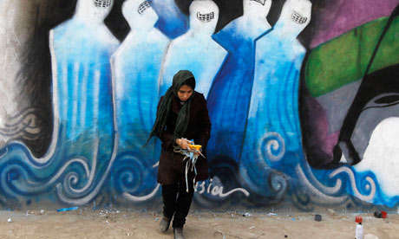
© Omar Sobhani/Reuters
Exhibit 2
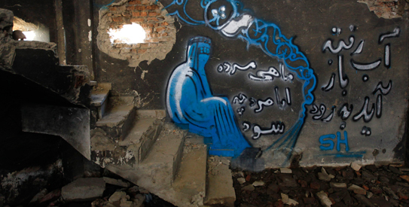
© Reuteurs

Exhibit 3
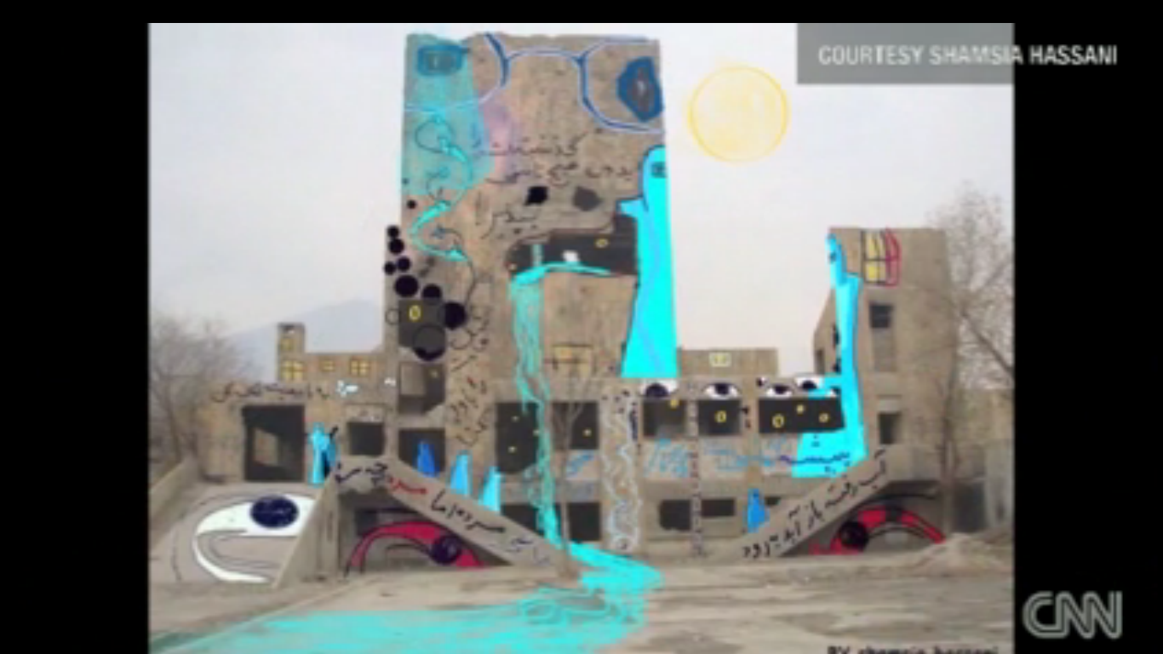

Bibliography
Afghanistan’s graffiti feminism. CNN video. March 8, 2012.
Center for Contemporary Arts Afghanistan. http://www.ccaa.org.af/
Comiteau, Lauren. Saving Afghanistan’s Art. January 8, 2008. Time.com
Kabul at work. http://www.kabulatwork.tv/chapter/culture-clash/graffiti-artist-pages/
Lekic, Slobodan and Riechmann, Deb. Withdrawal from Afghanistan: 40,000 Troops to Leave War Zone by End of 2012. Huffington Post. 11/29/11
Mashal, Mujib. Old bounds, new art. Himal Mag. January 2011.
Peace Unveiled. Women War and Peace. PBS video. http://video.pbs.org/video/2160652241
Reuters. Afghan artists use graffit to depict war, oppression. March 6, 2012
Shorthose, Jim. Unlawful Instruments and Goods’: Afghanistan, Culture and the Taliban. Capital and Class No. 78. 2002.

Mashal
Comiteau9
Mashal
Reuters
Peace Unveiled
Lekic

